WMCD Rathnayake

IT24100039

1. Calculate the population mean and population standard deviation of the laptop bag weights.  
   A computer screen shot of a program

   Description automatically generated
2. Draw 25 random samples of size 6 (with replacement) and calculate the sample mean and sample standard deviation for each sample.

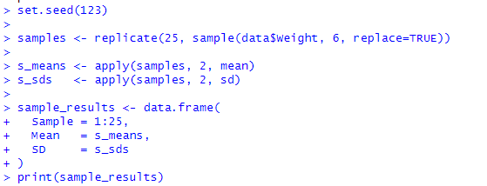

Sample Mean SD

1 1 2.530000 0.1513935

2 2 2.573333 0.1191078

3 3 2.473333 0.1718914

4 4 2.591667 0.1345239

5 5 2.456667 0.2749303

6 6 2.401667 0.2544340

7 7 2.590000 0.2167026

8 8 2.466667 0.4530195

9 9 2.401667 0.2230172

10 10 2.335000 0.3237746

11 11 2.586667 0.1706068

12 12 2.378333 0.3235686

13 13 2.381667 0.2993604

14 14 2.465000 0.2314951

15 15 2.485000 0.1745566

16 16 2.451667 0.2762909

17 17 2.385000 0.2042303

18 18 2.338333 0.2436733

19 19 2.428333 0.2481465

20 20 2.551667 0.2654367

21 21 2.538333 0.1708118

22 22 2.466667 0.2451666

23 23 2.470000 0.2405826

24 24 2.448333 0.2792430

25 25 2.475000 0.2358601

3. Calculate the mean and standard deviation of the 25 sample means and state the relationship of them with true mean and true standard deviation.

